 | 7.1.11 Editors - 3D Viewport - Header - Mesh - Edit mode - Edge Menu
Table of content
Detailed Table of content 1
Edit Mode - Edge Menu 3
Legacy 3
Bridge Edge loops 7
Subdivide 8
Un-Subdivide 10
Rotate Edge CW 10
Rotate Edge CCW 10
Edge Crease 11
Edge Bevel Weight 11
Mark Sharp 12
Clear Sharp 12
Mark Sharp from Vertices 12
Clear Sharp from Vertice 12
Mark Freestyle Edge 12
Set Sharpness by Angle 13
Clear Freestyle Edge 13

Detailed Table of content

Detailed table of content
Detailed Table of content 1
Edit Mode - Edge Menu 3
Legacy 3
Bevel Edges 4
Last Operator Bevel 4
Width type 4
Width 4
Segments 4
Profile 4
Vertex only 4
Clamp Overlap 4
Loop Slide 4
Mark Seams 5
Mark Sharp 5
Material 5
Harden Normals 5
Face Strength Mode 5
None 5
New 5
Affected 5
All 5
Outer Miter 5
Sharp 5
Patch 5
Arc 5
Inner Miter 6
Sharp 6
Arc 6
Spread 6
Edge Slide 6
Header Values 6
Last Operator Edge Slide 6
Factor 6
Even 6
Flipped 7
Clamp 7
Correct UV's 7
Offset Edge Slide 7
Last Operator Offset Edge Slide 7
Cap Endpoint 7
Edge Slide Factor 7
Even 7
Flipped 7
Clamp 7
Correct UV's 7
Bridge Edge loops 7
Last Operator Bridge Edge loops 8
Connect Loops 8
Merge 8
Merge Factor 8
Twist 8
Number of Cuts 8
Interpolation 8
Smoothness 8
Profile Factor 8
Profile shape 8
Subdivide 8
Last Operator Subdivide 9
Number of Cuts 9
Smoothness 9
Create N-Gons 9
Quad Corner Type 9
Fractal 9
Along Normal 9
Random Seed 9
Subdivide Edge ring 9
Last Operator Subdivide Edge ring 9
Number of Cuts 9
Interpolation 9
Smoothness 10
Profile Factor 10
Profile Shape 10
Un-Subdivide 10
Last Operator Un-Subdivide 10
Iterations 10
Rotate Edge CW 10
Last Operator Rotate Selected Edge 10
Counter Clockwise 10
Rotate Edge CCW 10
Last Operator Rotate Selected Edge 10
Counter Clockwise 10
Edge Crease 11
Last Operator Edge Crease 11
Factor 11
Edge Bevel Weight 11
Last Operator Edge Bevel Weight 11
Factor 11
Mark Sharp 12
Last Operator Mark Sharp 12
Vertices 12
Clear Sharp 12
Last Operator Mark Sharp 12
Vertices 12
Mark Sharp from Vertices 12
Clear Sharp from Vertice 12
Mark Freestyle Edge 12
Set Sharpness by Angle 13
Last Operator Set Sharpness by Angle 13
Angle 13
Extend 13
Clear Freestyle Edge 13

Edit Mode - Edge Menu
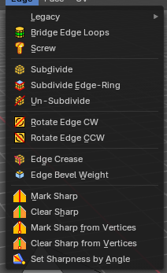

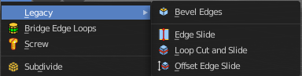
Legacy
The legacy sub menu contains tools that exists in the tool shelf already. It's the old way to do things. Different to the tools in the tool shelf, these tools are usually modal. And performs once. You have to call them again in case you want to repeat the tool.

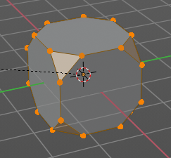
Bevel Edges
The Bevel Tool adds a bevel to the selected Edges.
Usage: first select the geometry that you want to bevel. Then activate the tool and drag the mouse. You need to drag quite a bit outwards until you see an effect. So don't wonder when the mouse movement seem to do nothing. You can also adjust the amount in the Last Operator Bevel panel afterwards.

In the header you can see further advice. And the current values for the bevel.

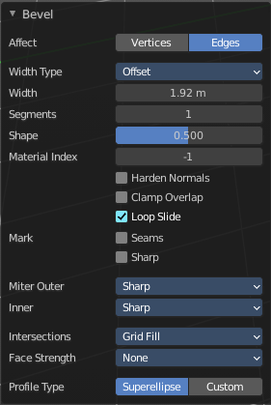
Last Operator Bevel

Width type
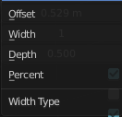
Width Type is a drop-down box choose the Amount type for the bevel action.

Width
The Bevel amount.

Segments
How many segments gets created

Profile
Controls the Profile shape. 0.5 means round.

Vertex only
Bevel Vertices only.

Clamp Overlap
Do not allow beveled geometry to overlap each other.

Loop Slide
Prefer slide along edge to even widths.

Mark Seams
Mark seams along the beveled edges.

Mark Sharp
Mark the beveled edges sharp.

Material
Material for beveled faces. -1 is the surrounding material.

Harden Normals
Match the normals of the new faces to the adjacent faces.

Face Strength Mode
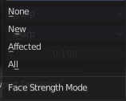
Face Strength Mode can be used in conjunction with Weight Normals Modifier (with the 'Face Influence' option checked). Set if and how the face strength at creation gets set.

None
Don't set face strength.

New
Set the face strength of new faces along edges to Medium. And the face strength of new edges at vertices to Weak.

Affected
In addition to those set for the New case, also set the faces adjacent to new faces to have strength Strong.

All
In addition to those set for the Affected case, also set all the rest of the faces of the model to have strength Strong.

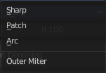
Outer Miter
How the outer miter is set. Miter is how the bevel rounding at a corner is done.


Sharp
Creates a sharp miter.

Patch

This replaces the outside vertex of a miter with 3 vertices. And uses a patch pattern there.

Arc

This replaces the vertex of a miter with 2 vertices, joined by an arc. A separate Spread parameter says how far to move the vertices away from their original position.

Inner Miter
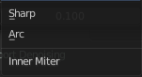
How the inner miter is set. Miter is how the bevel rounding at a corner is done.

Sharp
Creates a sharp miter.

Arc
This replaces the vertex of a miter with 2 vertices, joined by an arc. A separate Spread parameter says how far to move the vertices away from their original position.

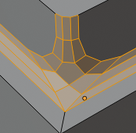
Spread
Belongs to inner miter method Arc. Adjust how strong the inner radius is bent.

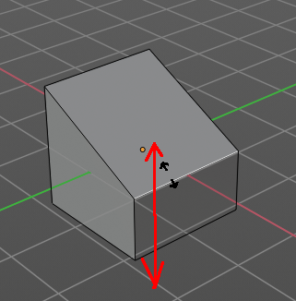
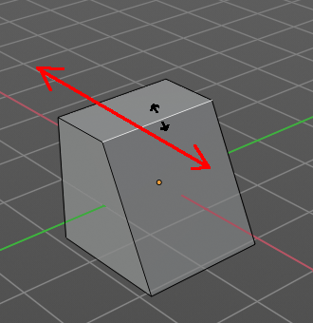
Edge Slide
Same tool than in the tool shelf. Edge Slide slides the selected edge along the face that it is part of. This is for the edge at a cube into two possible directions.
This tool requires to have at least one edge selected.

Header Values
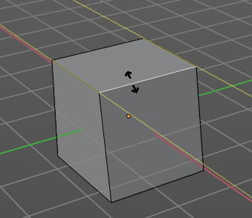
The header values shows you the current transformation. But also hints towards a hotkey.
Holding down ALT will allow you to slide the edges behind the limits of the guide edge. Yellow infinite guide lines appears.

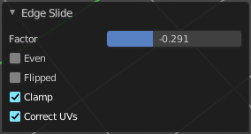
Last Operator Edge Slide

Factor
Factor is a sliding box Adjust the slide strength numerically. The width of the face is the 0-1 range.

Even
Make the Edge loop match the shape of the adjacent edge loop.

Flipped
When Even Mode is active, flips between the two adjacent edge loops.

Clamp
Clamp within the edge extend.

Correct UV's
Correct UV's corrects the UV's while editing the geometry.

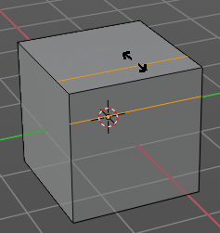
Offset Edge Slide
The tool is called Offset Edge Loop Cut in the tool shelf. Slides the selected edge(s).
Usage: select the edges that you want to slide. Click to confirm.
You can adjust the sliding amount in the Last Operator Offset Edge Slide.

Last Operator Offset Edge Slide

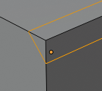
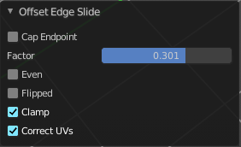
Cap Endpoint
Cap Endpoint caps the loose edges.

Edge Slide Factor
Adjust the slide amount.

Even
Make the edge loop match the shape of the adjacent edge loop

Flipped
When Even mode is active, flips between the two adjacent edge loops.

Clamp
Clamp within the edge extend.

Correct UV's
Corrects the UV's when modifying the geometry.

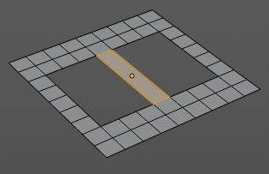
Bridge Edge loops
The Bridge edge loops tool bridges selected edges, and adds a polygon between them. You need to have at least two edges selected.

Last Operator Bridge Edge loops

Connect Loops
Choose the method how to deal with bridging multiple loops.

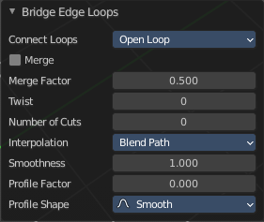
Merge
With merge ticked it will not create a bridge face, but merge the selected edges.

Merge Factor
The merge factor determines at which distance between the selected edges the merge happens. 0.5 is the middle of the selected edges.

Twist
The twist offset for closed loops.

Number of Cuts
Adds cuts to the bridge face.

Interpolation
Choose the interpolation mode for the cuts.

Smoothness
Adjust the smoothness for the cuts.

Profile Factor
Adjust the profile factor for the cuts.

Profile shape
Adjust the profile shape for the cuts.

Subdivide
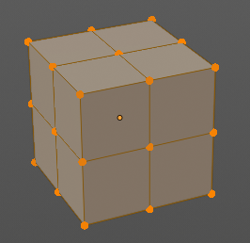
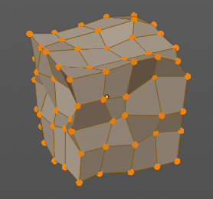
Subdivide divides the selected edges. It subdivides the involved faces too, and can create new vertices.
A more unknown functionality is that it can also randomize the result with the Fractal slider in the Last operator panel.

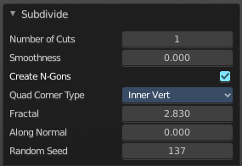
Last Operator Subdivide

Number of Cuts
The number of cuts defines the amount of subdivisions.

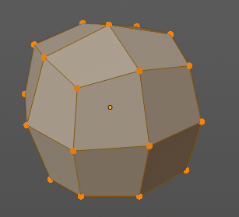
Smoothness
This value defines how smooth the subdivision result is. From flat to bent.

Create N-Gons
Create N-Gons if required. Else subdividing N-Gons creates Tris.

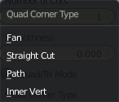
Quad Corner Type
Adjust the corner type.

Fractal
Randomize the selected vertices.

Along Normal
When randomized, this value defines how strong the subdivision follows the normals of the initial vertices.

Random Seed
Randomizing value for fractal randomizing.

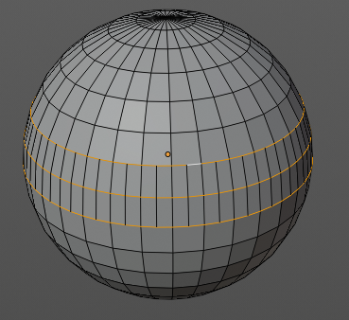
Subdivide Edge ring
Subdivides the selected edge ring(s).

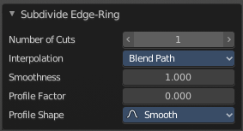
Last Operator Subdivide Edge ring

Number of Cuts
Adjust the number of cuts for the subdivision.

Interpolation
Choose an interpolation method for the new geometry.
Linear ends in an equal division and a flat result. Blend Surface interpolates the surrounding geometry. And can end in a curvy result.

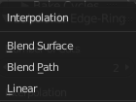
Smoothness
The Smoothness factor for the interpolation.

Profile Factor
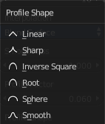
The profile strength.

Profile Shape
A drop-down box where you can define a profile for the generated geometry.

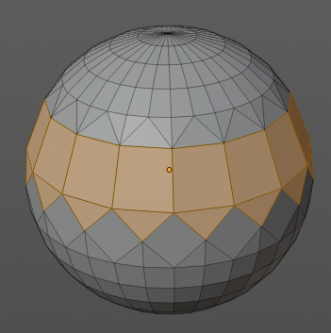
Un-Subdivide
Decimates the geometry by trying to make one quad out of four quads. But can also end in Tris where this is not possible.

Last Operator Un-Subdivide

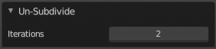
Iterations
Number of iterations. This means how deep the calculation should go. One level of SDS, two levels, three levels, etc.. Down to the point where you cannot decimate any geometry anymore.

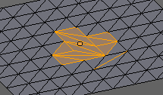
Rotate Edge CW
Rotate Edge rotates the selected edge clockwise.

Last Operator Rotate Selected Edge

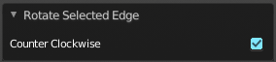
Counter Clockwise
Rotate selected edges counter clockwise.

Rotate Edge CCW
Rotate Edge rotates the selected edge counter clockwise.

Last Operator Rotate Selected Edge

Counter Clockwise
Rotate selected edges counter clockwise.

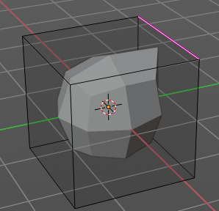
Edge Crease
When you use a Subdivision Surface Modifier, then you can define the sharpness of selected edges with this tool. Crease edges will be marked colored in edit mode.
You will see a value in the header that indicates the current strength when you activate the tool. Move with the mouse to increase or decrease the value. Or type in a value while you are in this mode. You can also scale into negative range.
A negative crease value will subtract from the current active crease value in case it exists already from a former crease operation. A Crease value of -1 removes the crease from this edge.

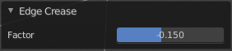
Last Operator Edge Crease

Factor
Adjust the crease factor.

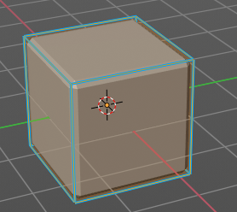
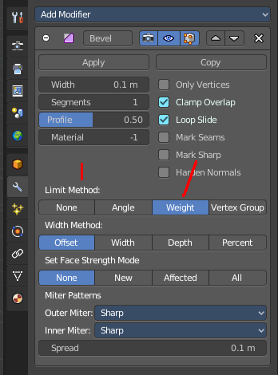
Edge Bevel Weight
This tool adjusts the edge bevel weight for selected edges when you use the Bevel modifier at the mesh.
You need to have set the limit method to Weight. This way you can achieve a bevel weight for every individual selected edge if you want, and achieve different bevel strengths at the mesh.

You will see a value in the header that indicates the current strength when you activate the tool. Move with the mouse to increase or decrease the value. Or type in a value while you are in this mode. You can also scale into negative range.
A negative Edge Bevel Weight value will subtract from the current active crease value in case it exists already from a former crease operation. An Edge Bevel Weight value of -1 removes the weight from this edge.

Last Operator Edge Bevel Weight

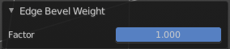
Factor
Adjust the Edge Bevel Weight factor.

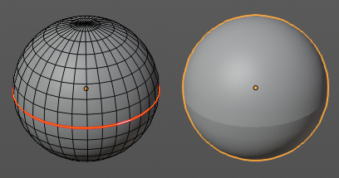
Mark Sharp
Mark Sharp is a tool that you need for the Edge Split modifier. Marked edges are displayed and rendered as sharp edges.
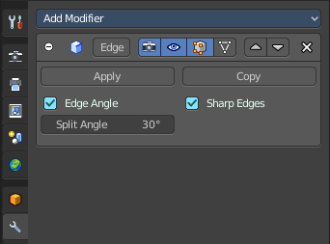

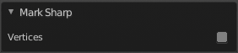
Last Operator Mark Sharp

Vertices
Calculate by the selected vertices instead of edges to mark the edges.

Clear Sharp
Clears formerly as sharp marked selected edges.

Last Operator Mark Sharp

Vertices
Calculate by the selected vertices instead of edges to mark the edges.

Mark Sharp from Vertices
Same as Mark Sharp, but with Vertices already ticked in the Adjust Last Operation panel. The calculation happens from the selected vertices instead of the selected edges.

Clear Sharp from Vertice
Same as Clear Sharp, but with Vertices already ticked in the Adjust Last Operation panel. The calculation happens from the selected vertices instead of the selected edges.

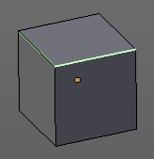
Mark Freestyle Edge
Freestyle is a comic renderer that is included in Bforartists. Mark Freestyle Edges marks the selected edges as Freestyle feature edges.

Set Sharpness by Angle
Set edge sharpness based on the angle between neighboring faces.

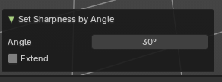
Last Operator Set Sharpness by Angle

Angle
Sets the angle the sharp edges will be defined by. Any edge angle over this angle will be marked.

Extend
Add new sharp edges without clearing the existing sharp edges.

Clear Freestyle Edge
Freestyle is a comic renderer that is included in Bforartists. Clear Freestyle Edges unmarks the selected edges as Freestyle feature edges.

